

**ROC COMPANY ANALYSIS**

Department of electronics and communication   
  
A Comprehensive roc company analysis solution

**Team members**: KIRUTHIKA.G (113321106044)

DHANISHA MARY..C (113321106020)

INDHUJA.V( 113321106034)

BINU ALLEN INFANTA.J( 113321106038)

KEERTHI.B (113321106041)

**PROBLEM STATEMENT:**

The objective of this project is to leverage advanced Artificial Intelligence techniques to perform an in-depth exploration and predictive analysis on the master details of companies registered with the Registrar of Companies (RoC). The AI-driven analysis aims to uncover hidden patterns, discover valuable insights into the company landscape, and forecast future registration trends. By applying cutting-edge AI algorithms, the study seeks to identify unique characteristics and relationships among registered companies, enabling a more sophisticated understanding of the business ecosystem in Tamil Nadu. The ultimate goal is to develop predictive models that can anticipate future company registrations and contribute to informed decision-making for businesses, investors, and policymakers

**INTRODUCTION:**

In the ever-evolving world of technology, Artificial Intelligence (AI) continues to revolutionize various industries. One such domain that can greatly benefit from AI is the thorough analysis and prediction of master details of RoC registered companies. By harnessing the power of AI, we can delve deep into the intricacies of these organizations, enabling us to unlock valuable insights and make informed decisions. Let's explore the limitless potential of AI in understanding and forecasting RoC registered companies' vital information.

**EXPLORING THE MASTER DETAIL:**

By utilizing AI, we can delve deeper into the master details of RoC registered companies. This includes analyzing company financials, organizational structure, key shareholders, and other crucial information. AI algorithms uncover hidden insights and patterns within this data, enabling better risk assessment, investment decisions, and strategic planning for businesses operating in this ecosystem.

**INNOVATON IDEAS:**

**Financial Performance Key**

financial data (revenue, profit, assets, liabilities)Trends over the yearsGraphs/Charts for visual representation

**SWOT Analysis**

Strengths

Weaknesses

Opportunities

Threats

**Incremental Innovation**:

This approach focuses on making small improvements or enhancements to existing products or processes. It's about continuous refinement.

**Disruptive Innovation:**

This strategy seeks to create entirely new products, services, or processes that disrupt existing markets or industries. It's often associated with radical change.

**Importance of CSR:**

Enhances company reputation. Attracts socially conscious customers and investors. Fosters employee morale and engagement. Mitigates risks related to unethical behavior.

* **DATA SOURCE:**
* [**dataset:https://tn.data.gov.in/resource/company-master-data-tamil-nadu-upto-28th-february-2019**](https://tn.data.gov.in/resource/company-master-data-tamil-nadu-upto-28th-february-2019)
* **The above given dataset file is related to the roc company analysis**
* **This dataset includes the information about the industry related with the company.**
* **Data processing:** The given data is cleaned , analysed , data aggregation, data transformation and a report is generated
* **Geographic Analysis (if applicable): -** If your data includes geographic information, create geographic visualizations to explore how ROC varies by location.
* **Data Distribution:** Visualize the distribution of key variables. For ROC analysis, you'll want to look
* **Example visualizations: -** Choropleth maps to show ROC by region or country. at variables like ROC, NOPAT, and Invested Capital.
* **Data Distribution:** Visualize the distribution of key variables. For ROC analysis, you'll want to look **.**
* **Financial Ratios:Create or compute financial ratios that are relevant to ROC analysis, such as:**
* Debt-to-Equity Ratio: Total Debt / Total Equity
* Asset Turnover: Revenue / Total Assets
* Return on Assets (ROA): Net Income / Total Assets
* Return on Equity (ROE): Net Income / Total Equity
* at variables like ROC, NOPAT, and Invested Capital.
* **Time-Series Features:** If analyzing data over time, consider generating time-based features like:
  + Year-over-Year Growth: Calculate the percentage change in ROC compared to the previous year.
  + Rolling Averages: Compute moving averages of ROC over specific time periods to capture trends.
* **Hyperparameter Tuning:**Optimize the model's hyperparameters to improve its performance. This may involve grid search, random search, or more advanced techniques like Bayesian optimization.
* **Cross-Validation:**Use techniques like k-fold cross-validation to get a more robust estimate of the model's performance and ensure it generalizes well to new data.
* **Model Deployment:**Deploy the trained model into a production environment where it can make real-time predictions. This could be in a web application, a mobile app, or integrated into an existing system.

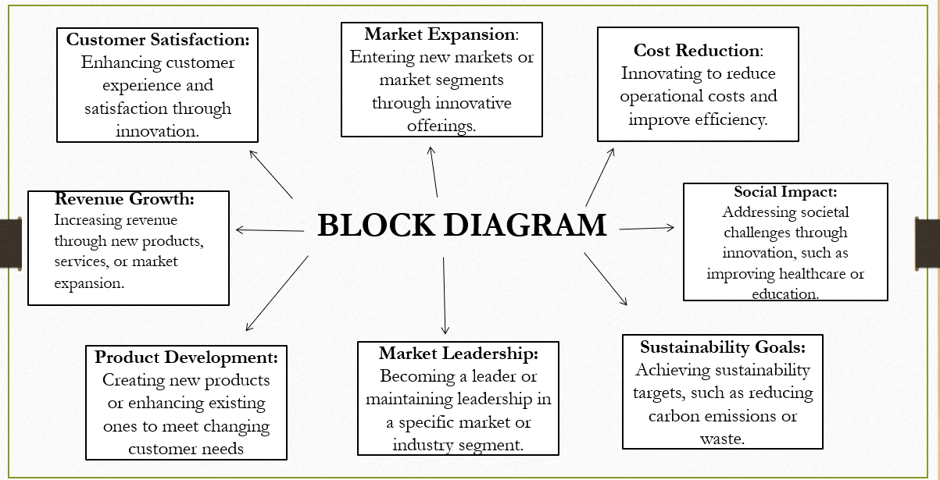

***TECHNIQUES FOR PREDICTING MASTER DETAIL:***

To predict master details of RoC registered companies, several techniques can be employed. These include machine learning algorithms, natural language processing, data mining, sentiment analysis, and network analysis. By utilizing these techniques, businesses can gain valuable insights into the operations and performance of RoC registered companies, enabling them to make informed decisions and mitigate risks effectively.

**CONCULSION:**

In conclusion, leveraging AI to predict master details of RoC registered companies offers immense potential for driving efficiency and accuracy in data analysis. By embracing advancements in machine learning, natural language processing, and emerging technologies like blockchain and cloud computing, we can revolutionize the way we gather, analyze, and secure company data. This will not only enhance decision-making but also ensure privacy and collaboration in the ever-evolving business landscape.